**Task**

* You have to Clone Github repository and set up your local dev environment. <https://github.com/shahzabartemis/artemis-fullstack-test>
* You have to build backend using the node js and integrate with our frontend (Provided in github repository)
* You will see page with the blocks and a Component of **Block (components/Block)  
    
  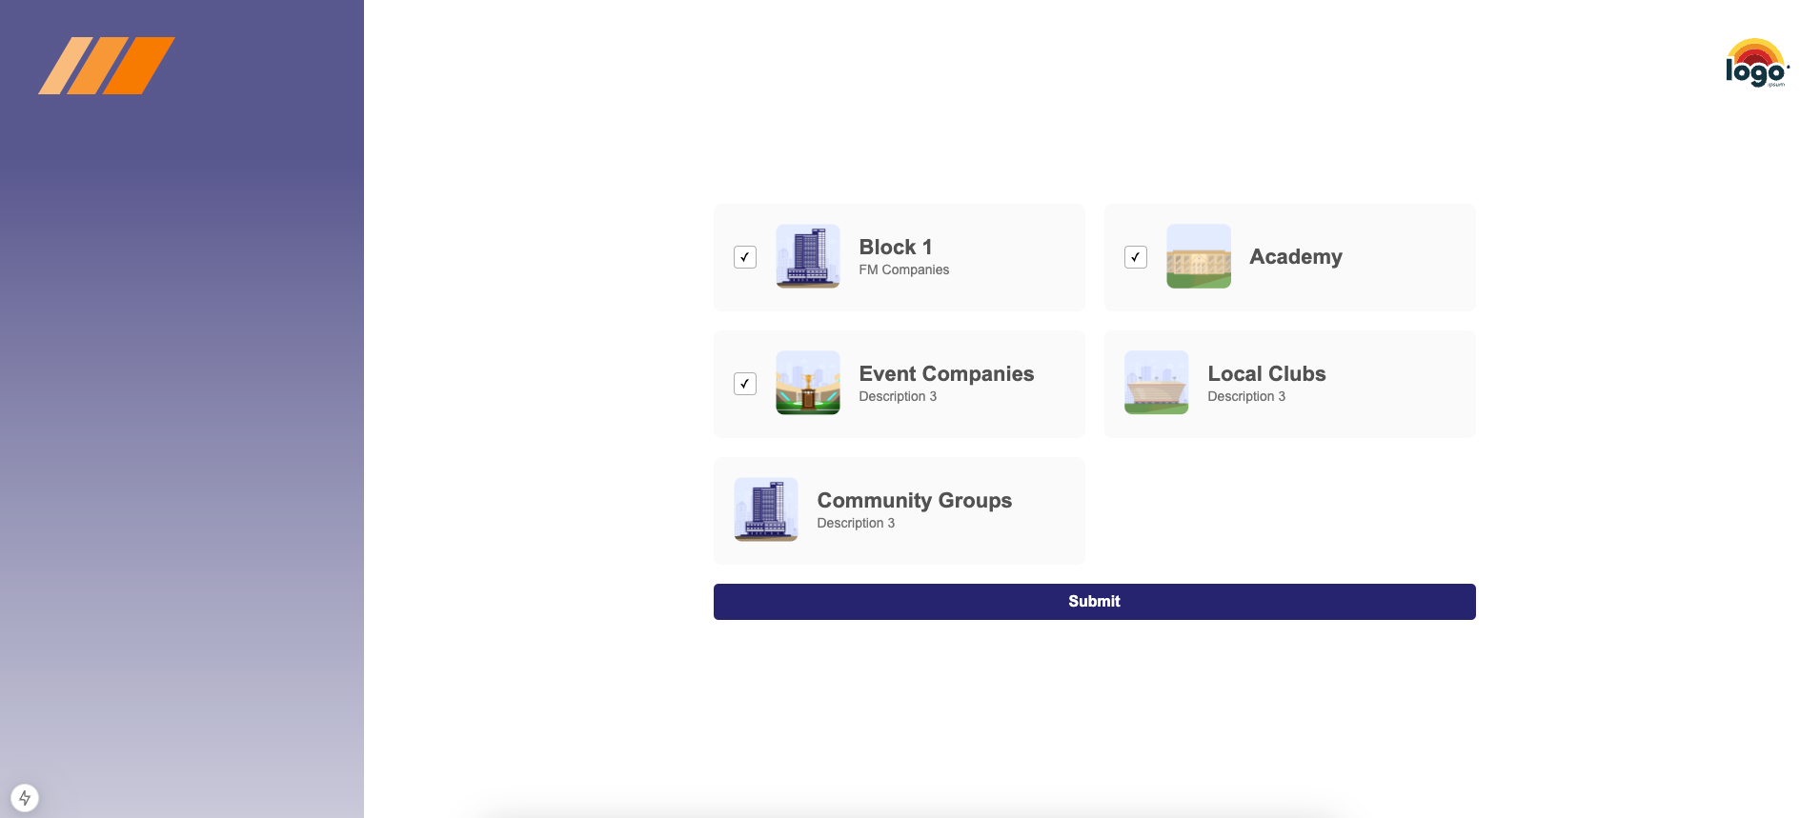**
* Currently Blocks are listed using JS Array. You have to link these blocks with the backend you will build.

**Functionality**

1. You will see the virtual check boxes in blocks, This can be set from the backend either a block will be single or grouped.
2. If you select a **Single Block** you need to add the ability to select only one single block.
3. If you select **Grouped Block** you need to add the ability to add select multiple grouped blocks.
4. **Submit Button** should be **disabled** until one or more blocks are not selected.
5. Submit Button Click should perform **validation** on **frontend** and **backend**
6. Data should be saved in MongoDB

**Submission**

* You will have to create a public repository on github and push your completed task in the repository for **frontend**.
* You will have to create a public repository on github and push your completed task in the repository for **backend**.
* Write a document on how to install and run your project